***Selenium Questions***

1. What is Selenium? What are the different Selenium components? Explain about Selenium Webdriver?

Ans:

[Selenium](http://qatechhub.com/selenium/) is an automation testing tool used to test web-based applications. Selenium is not a single tool but a suite of tools.

**Selenium Components:**

1. Selenium IDE (Integrated Development Environment).
2. Selenium RC(Remote Control)
3. Selenium WebDriver
4. Selenium Grid

### **Selenium IDE:**

Selenium IDE is a simple record and playback kind of tool which comes as an add-on for Mozilla Firefox only. It is used for prototype testing. Test cases written in IDE can be exported in many programming languages like Ruby, Java, C#, etc. Edit and Debug options along with record are also available. It is an excellent tool for beginners to understand the syntax of Selenium WebDriver.

### **Selenium RC:**

Selenium RC (Remote Control) was the first tool of Selenium Suite. Earlier it was known as JavaScript Executor. RC was the tool which made Selenium famous in the market.

It was the first tool which provided the support for multiple programming languages (JAVA, Ruby, Perl, PHP, Python, and C#).

#### **The architecture of Selenium RC:**

In Selenium RC, there is a manual process called **Selenium Server** is mandatory to start before execution,which acts as a middleman between the code and the browser. The commands (API’s) are sent to Server. It interprets the command and converts it into JavaScript and then JavaScript is injected to the browser. Now the browser executes the javascript and responds to a server, which again interprets the command and returns to code in the respective language.

### **Selenium WebDriver:**

Selenium WebDriver is the most important tool of the Selenium suite. Because of many limitations with RC, WebDriver was developed. It does not require any manual process like Selenium Server. There is a direct communication between code and browser.

#### **Features of Selenium WebDriver:**

* Open source
* Supports all the key vendors of the browser like Mozilla Firefox, Internet Explorer, Google Chrome, Safari, etc.
* Support Multiple languages like C#, JAVA, Ruby, Perl, Python, and PHP.
* Supports multiple platforms like Linux, Windows, MAC, etc.
* No middleman like Selenium RC server is required.
* Easy to remember API’s.
* Easy to integrate with Testing frameworks.
* Framework Development.
* Parallel Testing capabilities.

#### **The Architecture of Selenium WebDriver:**

As discussed earlier, Selenium WebDriver does not require Selenium Server as a middleman. The API’s written in WebDriver can directly interact with browsers.

### **Selenium Grid:**

It is the last component of the selenium suite and is used for parallel testing or distributive testing. It allows us to execute test scripts on different machines at same time.

There is a Hub which controls the execution on various machines, and there are multiple nodes on which actual implementation is done.

#### **Features of the Grid:**

* Parallel Execution on multiple nodes
* Platform Independent, support almost all Operating System
* Language Independent.
* Browser Independent supports almost all the main vendors of Browser.
* Fast Execution, reduces the execution time as test cases are executed parallelly.

#### **The Architecture of Selenium Grid:**

In Grid one of the systems is created as Hub. Hub works as a central point controlling all the nodes. Nodes are an actual machine on which execution is done.

1. How does Selenium communicate with the Web browsers?

Ans: For every Selenium command, there is a respective REST API in JSON Wire Protocol. Selenium works through API commands, such as GET and POST, and will function based on the Selenium script requests it gets. The requests then get sent to the HTTP server of the browser driver, as well as the browsers through HTTP.

1. What are the locators available to find an element using selenium?

Ans:

* className
* Id
* tagName
* linkText
* partialLinkText
* xPath
* name

1. Why ID is preferable than X-Path?

Ans: **ID Locators are much faster compared to other locator types such as XPath or OS Native locator mechanisms**. The main reason for this speed gain is that while locators such as XPath need to traverse the whole App source to find the element you are looking for, ID locators can be found in a single traversal of the code.

1. How to select value in dropdown?

Ans: A dropdown is represented by <select> tag and the options are represented by <option> tag. To select an option with its value we have to **use the selectByValue method and pass the value attribute of the option that we want to select as a parameter to that method**.

1. What is the difference between Absolute Path and Relative Path?

Ans:

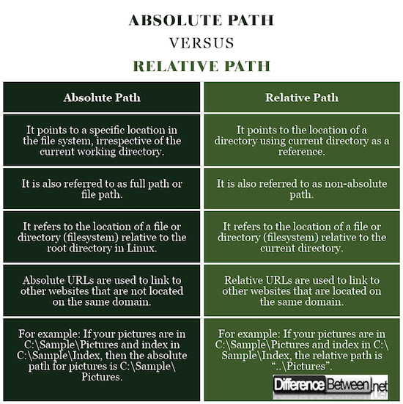

1. How to verify if the given radio button is selected or not(safari radio button)(it is not taught but you can explore)

Try here:

Ans: driver.findElement(By.*id*("j_idt87:console1:2")).click();

1. Difference between System.setProperty and webDriverManager?

Ans:

setProperty(“propertyName”, “value”)”. It implies that it sets the system property 'propertyName' to have the value 'value'. While testing with Selenium, you will make use of the setProperty method because the browser doesn't have a built-in server to run the automation code.

WebDriverManager is an open-source Java library that carries out the management (i.e., download, setup, and maintenance) of the drivers required by Selenium WebDriver (e.g., chromedriver, geckodriver, msedgedriver, etc.) in a fully automated manner.

1. Write the syntax for preceding and following Xpaths?

Syntax: parent::node()

The below example will selects the parent node of the input tag of Id='email'.

Ex: //input[@id='email']/parent::* the above can also be re-written as //input[@id='email']/

* Preceding axis: **preceding::node-test**
* Following axis: **following::node-test**

Here, **node-test** is the type of node that you want to select, such as **node()**, **element()**, **text()**, etc.

1. How to get an attribute value using selenium webdriver?

Ans:

We can get an attribute value of an element in the Selenium Webdriver. This is achieved with the help of the getAttribute method. In an html document, each element is identified with its tagname along with the element attributes with their values. To get an attribute value, we have to pass the element attribute as an argument to the getAttribute method.